Visualization Results and Explanations".

- SHAP (SHapley Additive exPlanations) summary plot:

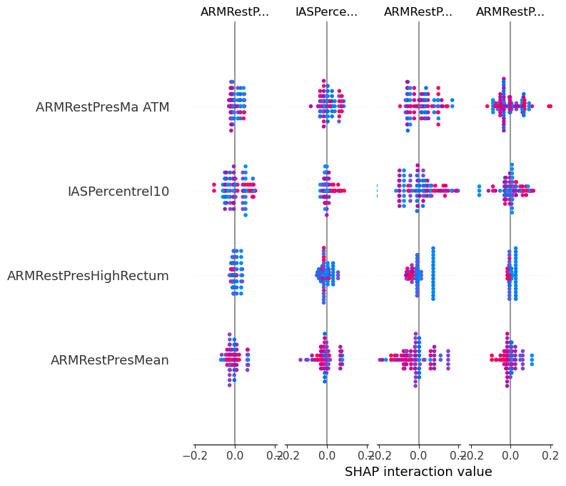
This SHAP summary plot helps identify which features are most influential in the model's predictions and how their values affect the output.
Feature Impact:
- ARMRestPresMean: Primarily neutral impact with some positive and negative influence in specific instances.
- ARMRestPresHighRectum: Varies in impact with notable deviations around zero.
- IASPercentrel10: Mixed impact, with both positive and negative SHAP values across instances.
- ARMRestPresMa ATM: Similar to other features, shows a combination of positive and negative influences.

- Feature Distributions by Histogram:
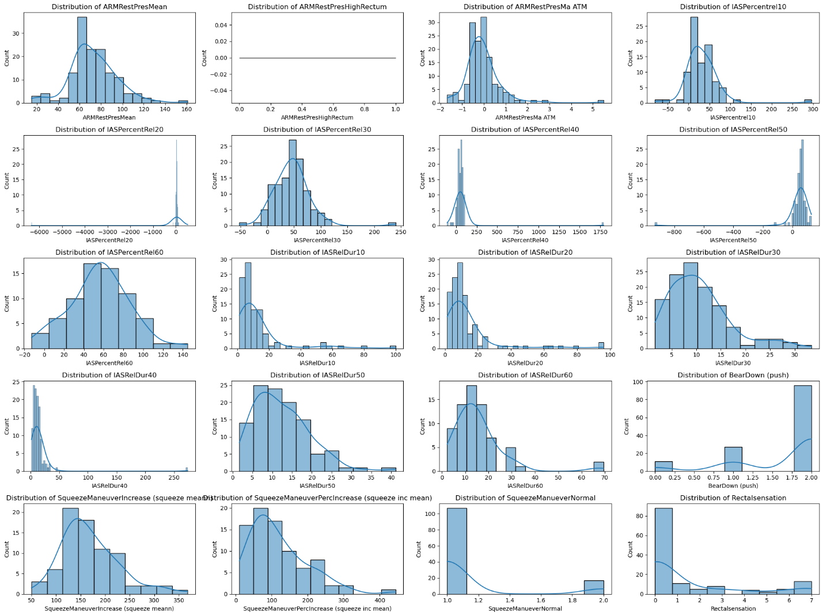

- Normal Distributions: ARMRestPresMean, ARMRestPresMa ATM, IASPercentRel30, IASPercentRel60, IASRelDur50, and SqueezeManeuverIncrease show approximately normal distributions.
- Skewed Distributions: Features like IASPercentrel10, IASPercentRel20, IASPercentRel40, IASRelDur10, IASRelDur40, IASRelDur60, and Rectalsensation show skewed distributions, often with long tails or outliers.
- Bimodal Distribution: BearDown (push) exhibits a bimodal distribution with two distinct peaks.
- Outliers: Several features have extreme outliers (e.g., IASPercentRel20, IASPercentRel40), indicating unusual values that may need special attention.
These histograms help understand the distribution and spread of each feature, providing insights into their characteristics and potential impact on the model's predictions.

- Pair Plot:
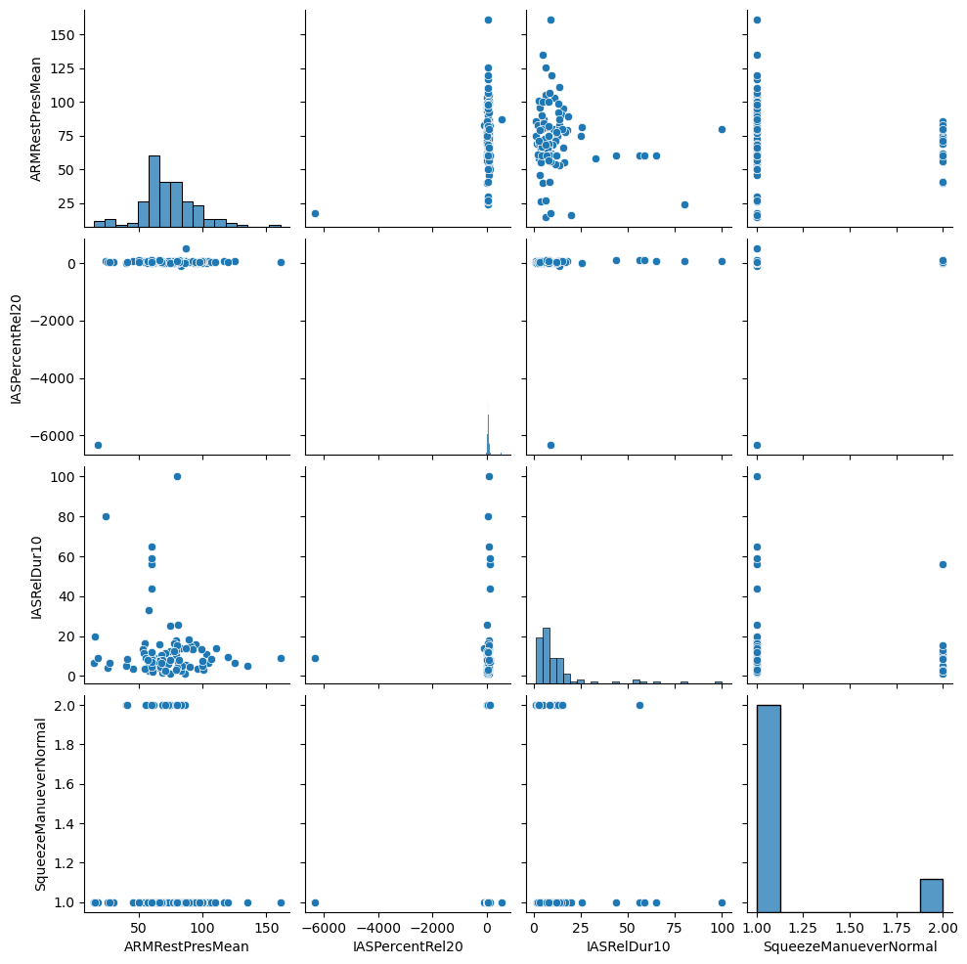

Interpretation:
- No Clear Relationships: The scatter plots indicate that there are no strong linear relationships between the pairs of features. Most plots show a wide scatter of points, suggesting independence or non-linear relationships.
- Outliers: IASPercentRel20 shows extreme outliers, which can significantly impact the model's performance and need to be handled appropriately.
- Feature Distributions: The histograms along the diagonal provide a quick overview of the distributions, confirming earlier observations about skewness and clustering.

- Correlation Heatmap:
This correlation heatmap visualizes the pairwise correlations between different features in the dataset. Each cell in the heatmap represents the correlation coefficient between two features, with values ranging from -1 to 1.
Interpretation:
- Strong Correlations:
  - Features like ARMRestPresMean and ARMRestPresMa ATM show a strong positive correlation, suggesting that as one increases, the other does as well.
  - The strong positive correlation between IASPercentrel10 and IASPercentRel20 indicates redundancy, suggesting these features might be representing similar information.
- Weak or No Correlations:
  - Many features show weak or no correlation with others, indicating they may provide unique information to the model.

- Potential Issues:
  - Features with extremely high correlations (e.g., IASPercentrel10 and IASPercentRel20) may need to be carefully considered to avoid multicollinearity, which can affect model performance and interpretability.

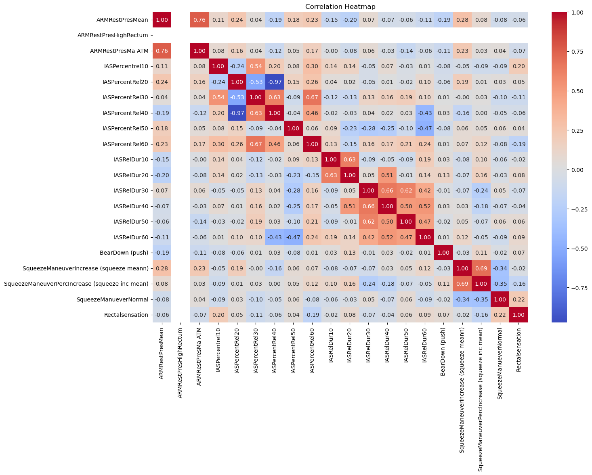

- ROC Curve and Precision-Recall Curve:
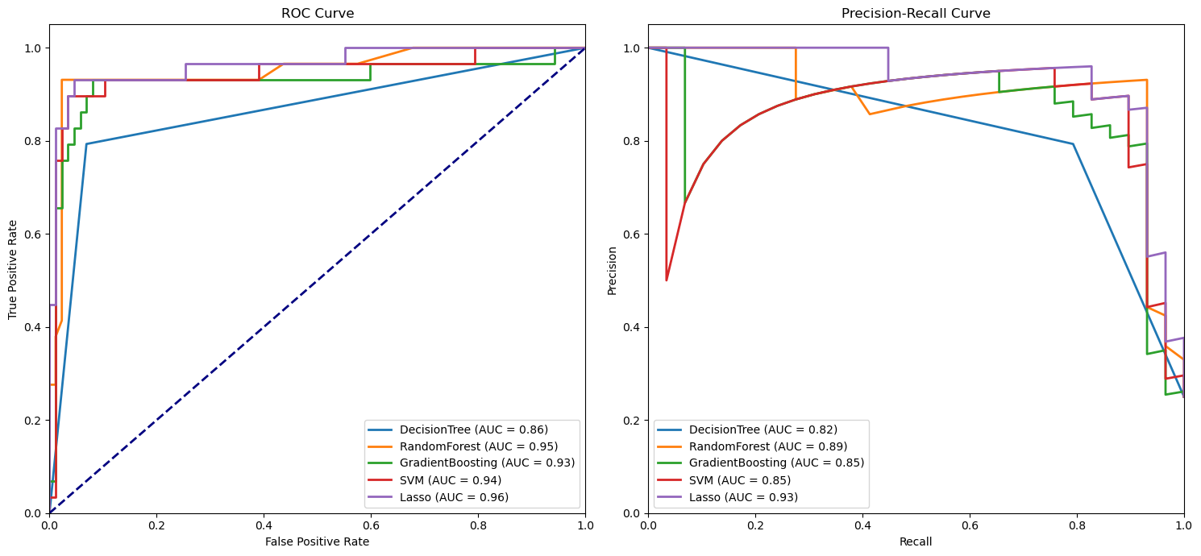

- ROC Curve: The Lasso model has the highest AUC, indicating the best ability to distinguish between classes, followed closely by Random Forest, SVM, and Gradient Boosting.
- Precision-Recall Curve: The Lasso model also shows the best trade-off between precision and recall, followed by Random Forest, SVM, and Gradient Boosting. The Decision Tree model has the lowest performance in both curves.

- Feature Importance Plots:
These two bar plots illustrate the importance of different features as determined by the Random Forest and Gradient Boosting models
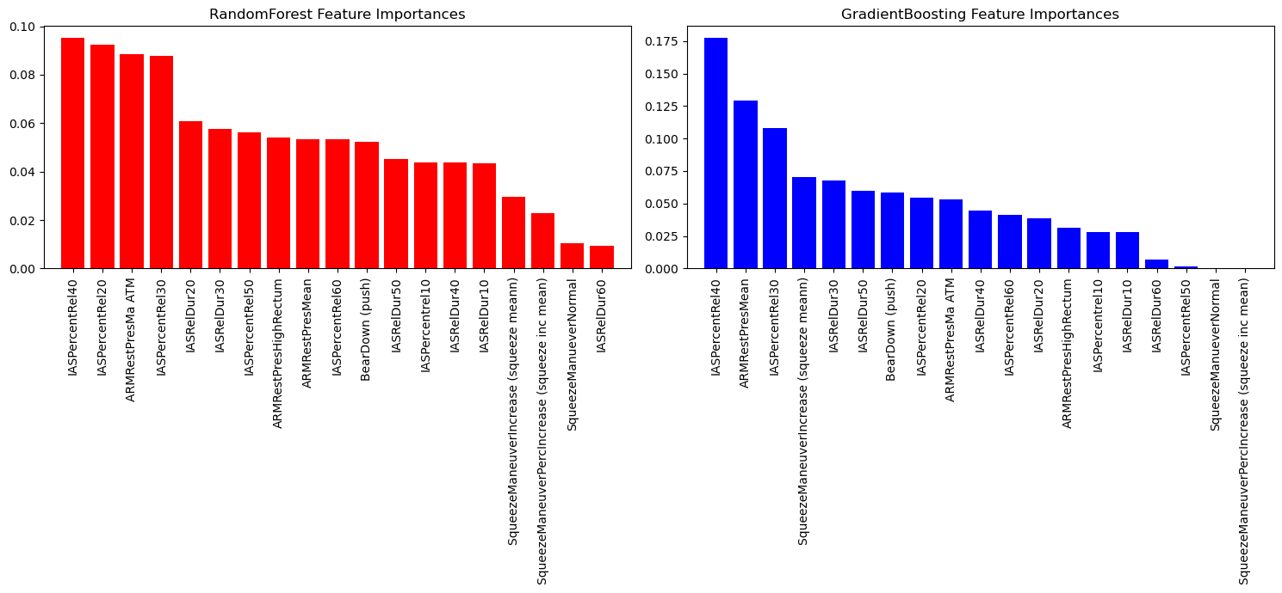

- Interpretation:

- Consistent Importance: Features like IASPercentRel40, IASPercentRel20, IASPercentRel30, and ARMRestPresMean are consistently important across both models, indicating their strong influence on model predictions.
- Model-Specific Differences: Some features have varying importance between the two models. For example, IASRelDur50 is more important in Gradient Boosting, while IASPercentRel20 is more crucial in Random Forest.
- Low Impact Features: Both models agree on the lower importance of features like SqueezeManeuverPercIncrease (squeeze inc mean) and SqueezeManueverNormal.

